2021 Carlsbad Chamber of Commerce Forty under Forty Nomination
Please help us select the recipients of the Carlsbad Chamber of Commerce
2021 Forty under Forty Award.
The nominated individuals should demonstrate leadership in their careers and actively participate in the community. All nominees will receive an application packet that will allow the individual to highlight his or her leadership and professional, charitable and/or civic engagement.
Winners will be determined by an independent panel of judges.
The 2021 recipients and their nominators will be honored at a banquet on Thursday, October 28, 2021 at the Pecos River Village Conference Center in Carlsbad, New Mexico. We hope you and your company will plan to attend.
Guidelines
- Nominations must be received no later than 5 PM on Tuesday, August 31, 2021.
- Please email completed nomination forms to cbad40@hotmail.com or drop them off at the Chamber office – 302 S Canal, Carlsbad, NM 88220.
- Nominees will be provided an application link by the end of August 2021 and be informed of eligibility requirements by the Carlsbad Chamber of Commerce.
- A company or individual may nominate up-to five people.
- Self-nominations are not permitted.
- The cost of nomination is $30/person. The nonrefundable fee may be paid via credit over the phone by calling (575-887-6516), in person at the Chamber office, or via invoice.
- Nominees must be 39 years of age or younger on or before Tuesday, August 31, 2021 to be eligible.
- A nominating business does not have to be a member of the Carlsbad Chamber of Commerce for a nominated individual to be considered as part of the 2021 Forty under Forty class. To learn more about the benefits of being a member of the Chamber please visit www.carlsbadchamber.com.
- For questions, please call Jeff Campbell (575-302-4751) or the Carlsbad Chamber of Commerce (575-887-6516).

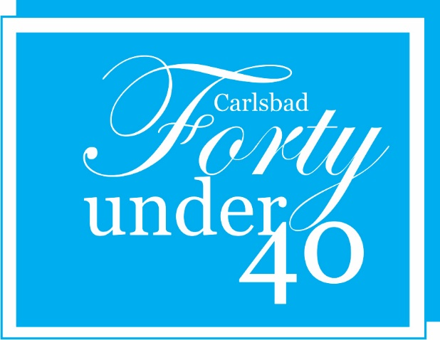

Carlsbad 40 Under 40 Nomination Form
About the Nominee
Name:_______________________________
Date of Birth:_________________________
Title:________________________________
Company:____________________________
Address:_____________________________
Daytime Phone:_______________________
E-Mail Address:_______________________
In 250 words or less, why should this person be nominated as a Carlsbad 40 Under 40 honoree? (Ideal candidates will have both work and community characteristics)
_____________________________________________________________________________________________________________________________________________________________________________________________________________________________________________________________________________________________________________________________________________________________________________________________________________________________________________________________________________________________________________________________________________________________________________________________________________________________________________________________________________________________________________________________________________________________________________________________
About the Nominator
Your Name:____________________________
Your Daytime Phone:____________________
Your E-Mail Address:____________________
NOTE: There is a $30 nonrefundable nomination fee
Please return form to cbad40@hotmail.com or drop off at the Carlsbad Chamber of Commerce,
302 S Canal St, Carlsbad, NM 88220. Questions, call (575) 302-4751
DEADLINE FOR NOMINATIONS IS August 31, 2021, 5 PM
Late Nominations will NOT be Accepted.

